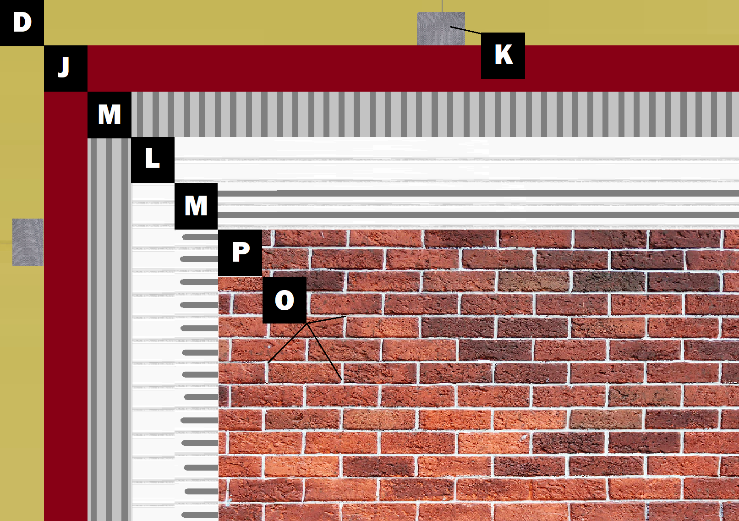

**Assembly E-1**

**Panel+ over Framing/Sheathing**

D – Sheathing (Exterior Gypsum, OSB, Plywood)

K – Old Mill Polylaminate Reinforcing Fabric

J – Old Mill Air & Water Barrier

M – Old Mill Brick & Panel Adhesive or Stone Adhesive

L – Old Mill EPS Foam Panel

P – Finish (Thin Brick, Stone, Tile or Manufactured Stone)

O – Old Mill Colored Pointing Mortar or Type S Masonry Mortar