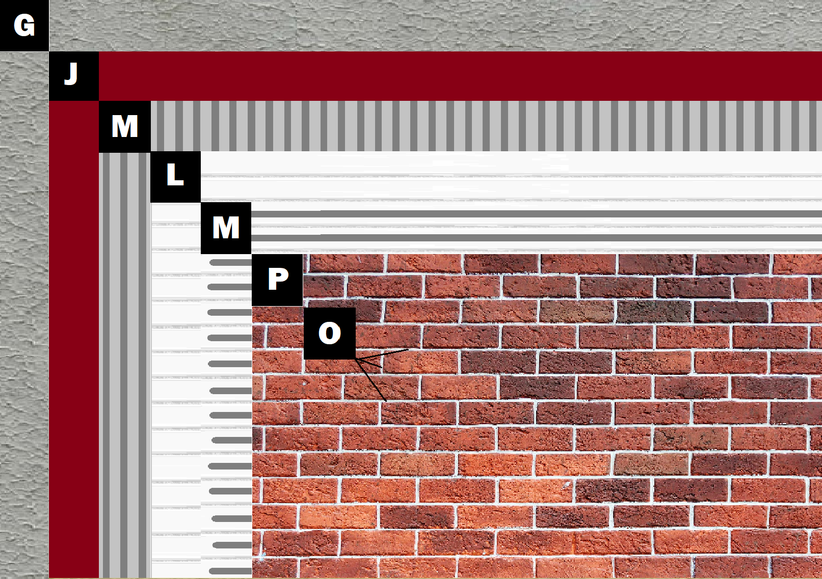

**Assembly E-3**

**Panel+ over Concrete, Stucco or EIFS Wall**

D – Concrete, Stucco or EIFS

J – Old Mill Air & Water Barrier

M – Old Mill Brick & Panel Adhesive or Stone Adhesive

L – Old Mill EPS Foam Panel

P – Finish (Thin Brick, Stone, Tile or Manufactured Stone)

O – Old Mill Colored Pointing Mortar or Type S Masonry Mortar