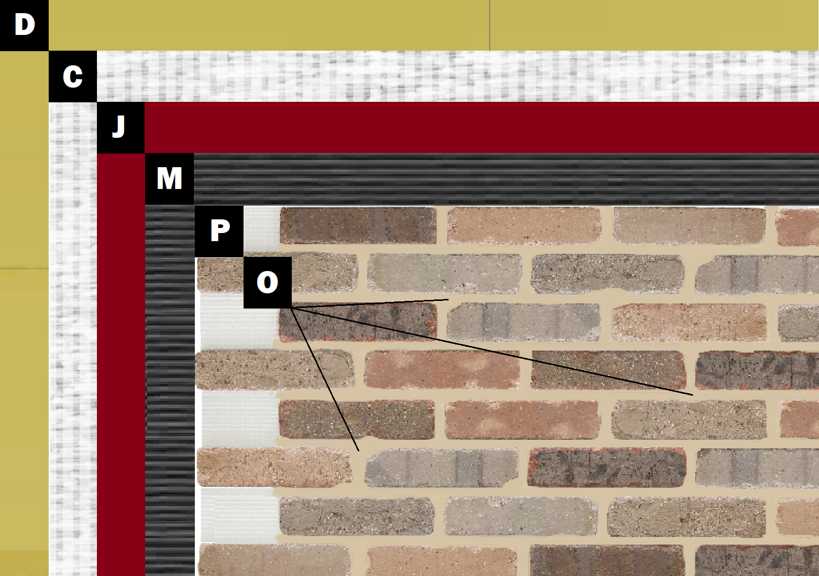

**Assembly E-6**

**Cement Board over Sheathing**

D – Sheathing

C – Cement Board (Tape & Float Joints per Manufacturer)

J – Old Mill Air & Water Barrier

M – Old Mill Brick & Panel Adhesive or Stone Adhesive

P – Finish (Thin Brick, Stone, Tile or Manufactured Stone)

O – Old Mill Colored Pointing Mortar or Type S Masonry Mortar