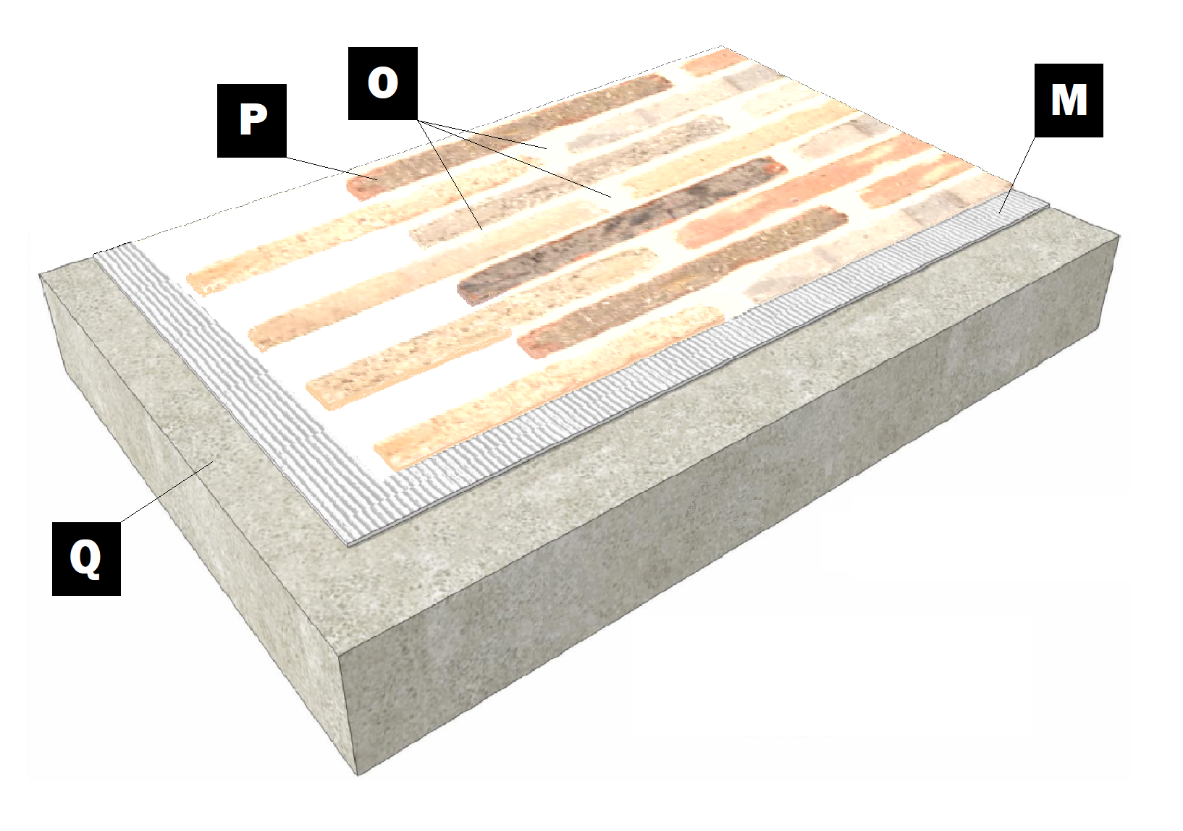

**Assembly E-7**

**Concrete Slab**

Q – Concrete Slab

M – Old Mill Brick & Panel Adhesive or Stone Adhesive

P – Finish (Thin Brick, Stone, Tile or Manufactured Stone)

O – Old Mill Colored Pointing Mortar or Type S Masonry Mortar