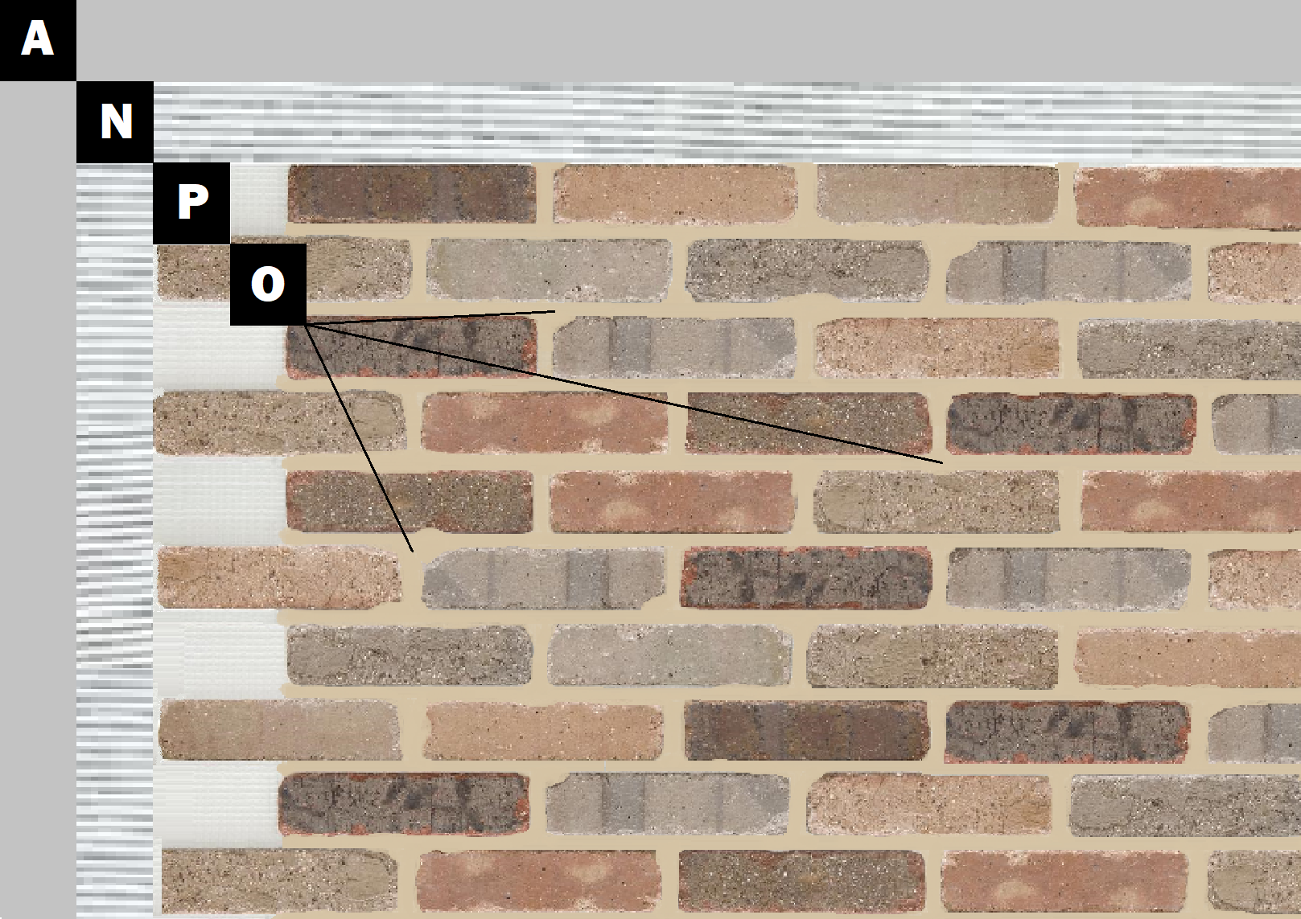

**Assembly I-1**

**Unfinished Drywall**

A – Unfinished Drywall

N – Old Mill Mastic

P – Finish (Thin Brick, Stone, Tile or Manufactured Stone)

O – Old Mill Colored Pointing Mortar or Type S Masonry Mortar