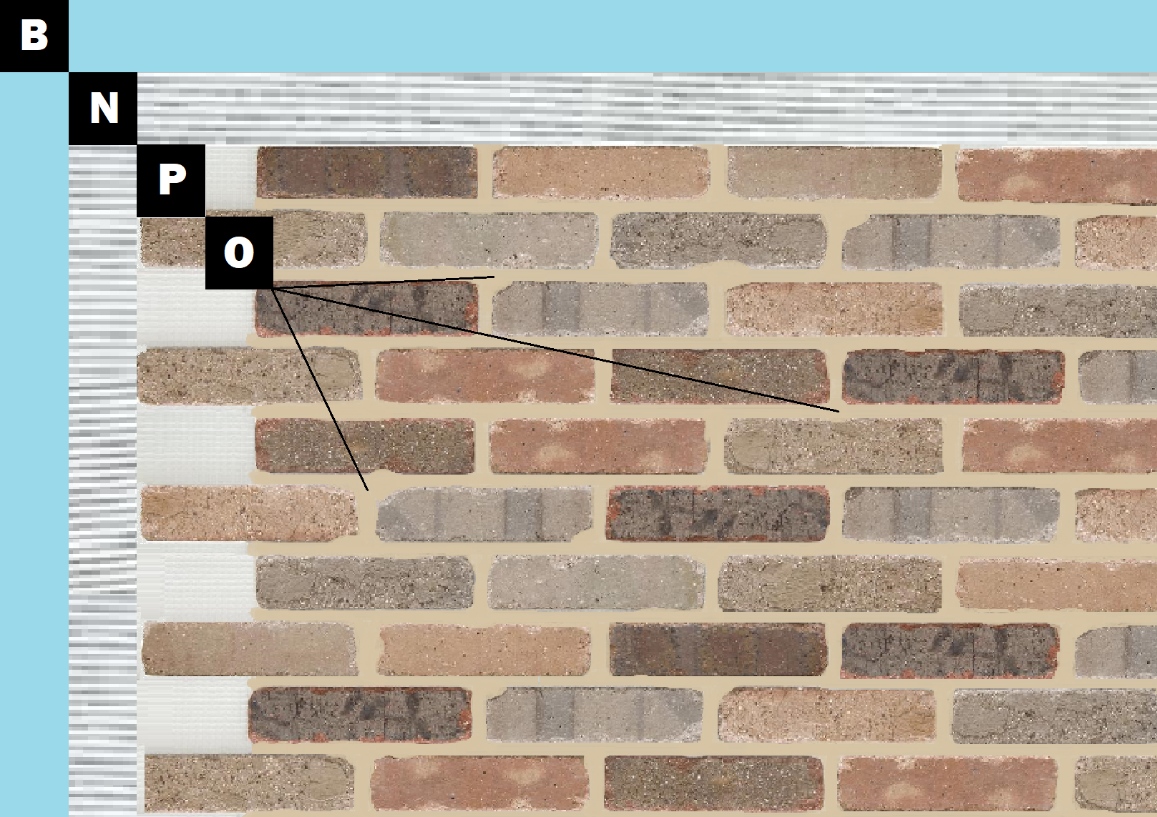

**Assembly I-2**

**Painted Drywall**

A – Painted Drywall

N – Old Mill Mastic

P – Finish (Thin Brick, Stone, Tile or Manufactured Stone)

O – Old Mill Colored Pointing Mortar or Type S Masonry Mortar