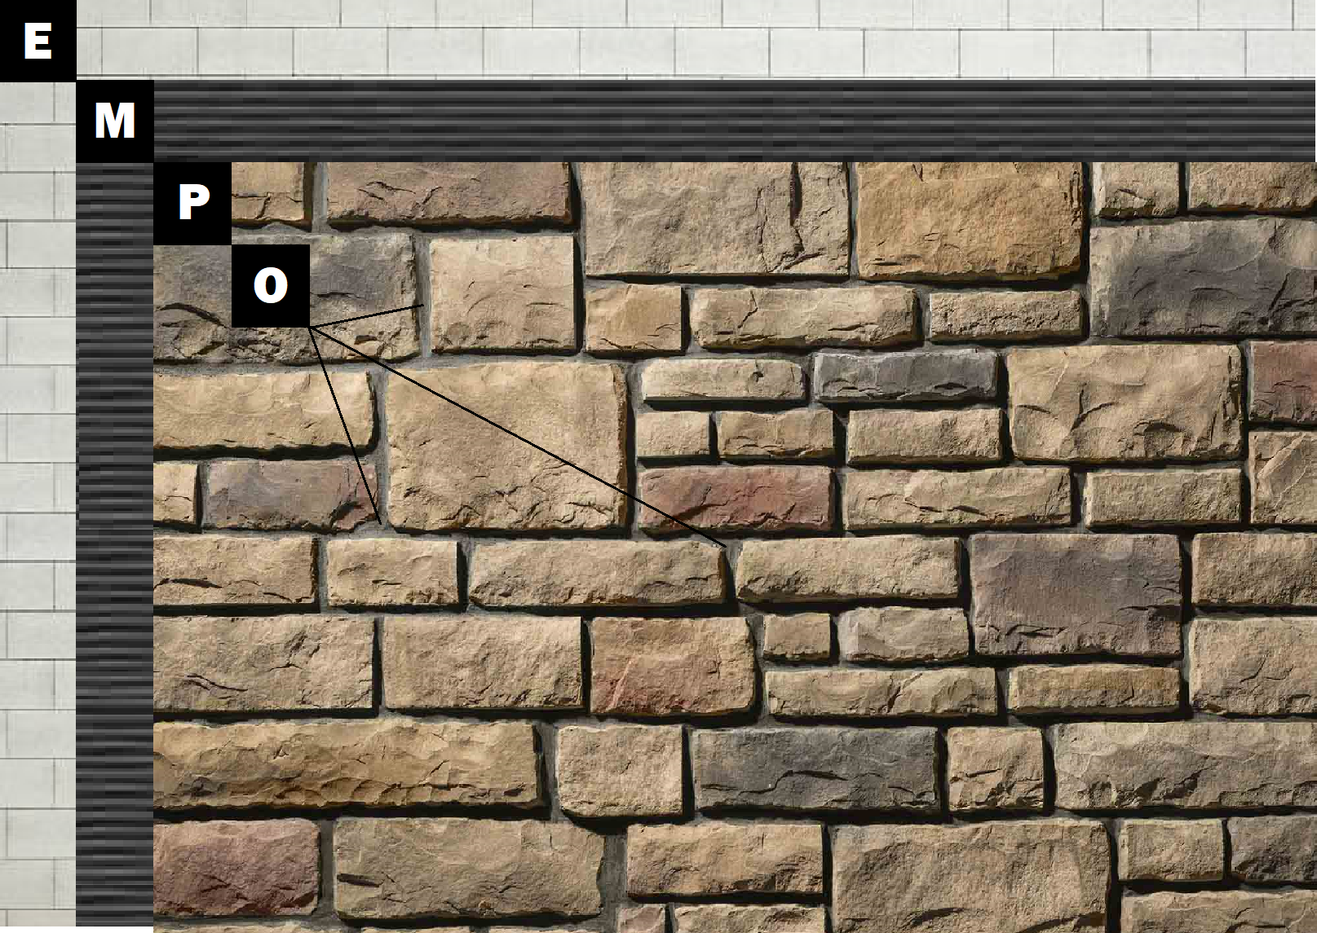

**Assembly I-4**

**Brick or CMU**

E – Brick or CMU

M – Old Mill Brick & Panel Adhesive or Stone Adhesive

P – Finish (Thin Brick, Stone, Tile or Manufactured Stone)

O – Old Mill Colored Pointing Mortar