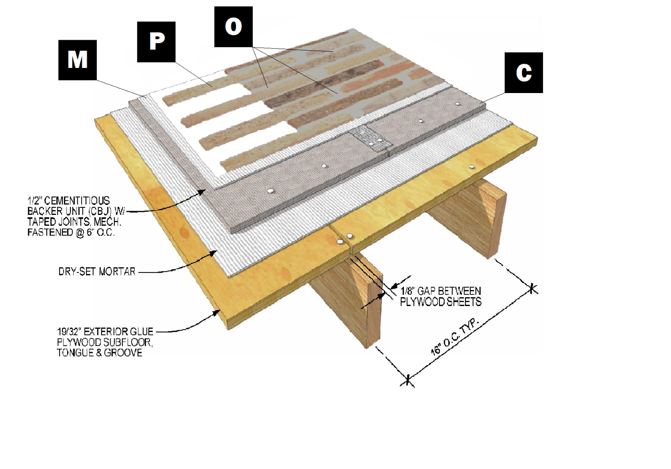

**Assembly I-7**

**Wood Subfloor with Cement Board**

C – Cement Board

M – Old Mill Brick & Panel Adhesive or Stone Adhesive

P – Finish (Thin Brick, Stone, Tile or Manufactured Stone)

O – Old Mill Colored Pointing Mortar