BRICK SIZE | APPROXIMATE WEIGHT | SIZE (INCHES)  (Bed Depth X Height X Length) | MODULAR BRICK EQUIVALENT | UNITS PER  SQ. FT. WALL  (Inc. 3/8" Joint) | SIZE (MM) | METRIC  UNITS/SQ M  (w/10MM Joint)
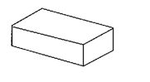 | MODULAR | 4.2 lbs. | 3-5/8" x 2-1/4" x 7-5/8" | 1 | 6.86 | 92 x 57 x 194 | 73.1
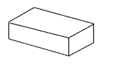 | STANDARD | 4.5 lbs. | 3-5/8" x 2-1/4" x 8" | 1.05 | 6.55 | 92 x 57 x 203 | 69.9
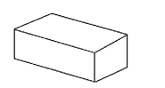 | JUMBO MODULAR | 5.1 lbs. | 3-5/8" x 2-3/4" x 7-5/8" | 1.22 | 5.76 | 92 x 70 x 194 | 61.3
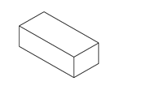 | JUMBO STANDARD | 5.9 lbs. | 3-5/8" x 2-3/4" x 8" | 1.28 | 5.5 | 92 x 70 x 203 | 58.7
 | JUMBO STANDARD (PLT 3) | 5.6 lbs. | 3-5/8" x 2-5/8" x 8" | 1.28 | 5.73 | 92 x 67 x 203 | 61.2
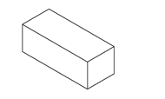 | SLIM JUMBO MODULAR | 4.1 lbs. | 3-1/8" x 2-3/4" x 7-5/8" | 1.22 | 5.76 | 76 x 70 x 194 | 73.6
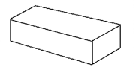 | QUEEN | 5.6 lbs. | 3-1/8" x 2-3/4" x 9-5/8" | 1.54 | 4.61 | 79 x 70 x 244 | 49.2
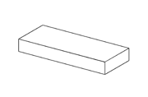 | ROMAN | 4.7 lbs. | 3-5/8" x 1-5/8" x 11-5/8" | 1.10 | 6.00 | 92 x 41 x 295 | 63.9
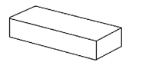 | NORMAN | 6.4 lbs. | 3-5/8" x 2-1/4" x 11-5/8" | 1.52 | 4.57 | 92 x 57 x 295 | 48.8
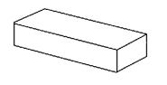 | JUMBO NORMAN | 7.8 lbs. | 3-5/8" x 2-3/4" x 11-5/8" | 1.86 | 3.84 | 92 x 70 x 295 | 41.0
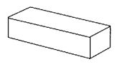 | SLIM JUMBO NORMAN | 7.2 lbs. | 3-1/8" x 2-3/4" x 11-5/8" | 1.86 | 3.84 | 79 x 70 x 295 | 41.0
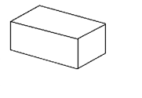 | MODULAR ECONOMO | 6.8 lbs. | 3-5/8" x 3-5/8" x 7-5/8" | 1.61 | 4.50 | 92 x 92 x 194 | 48.1
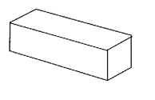 | UTILITY | 10.2 lbs. | 3-5/8" x 3-5/8" x 11-5/8" | 2.46 | 3.00 | 92 x 92 x 295 | 32.1
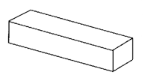 | MONARCH | 12.5 lbs. | 3-5/8" x 3-5/8" x 15-5/8" | 3.30 | 2.25 | 92 x 92 x 397 | 24.1
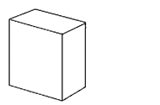 | QUAD | 14.1 lbs. | 3-5/8" x 7-5/8" x 7-5/8" | 3.39 | 2.25 | 92 x 194 x 194 | 24.1
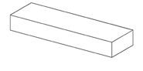 | AMBASSADOR | 8.8 lbs. | 3-5/8" x 2-1/4" x 15-5/8" | 2.05 | 3.43 | 92 x 57 x 397 | 36.6
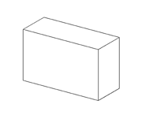 | DOUBLE UTILITY | 21.0 lbs. | 3-5/8" x 7-5/8" x 11-5/8" | 5.17 | 1.50 | 92 x 194 x 295 | 16.1
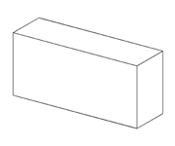 | DOUBLE MONARCH | 25.5 lbs. | 3-5/8" x 7-5/8" x 15-5/8" | 6.94 | 1.13 | 92 x194 x 397 | 12.1
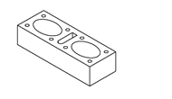 | 6" x 4" x 16" THRU-WALL | 16.0 lbs. | 5-5/8" x 3-5/8" x 15-5/8" | 3.30 | 2.25 | 143 x 92 x 397 | 24.1
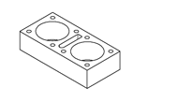 | 8" x 4" x 16" THRU-WALL | 21.8 lbs. | 7-5/8" x 3-5/8" x 15-5/8" | 3.30 | 2.25 | 194 x 92 x 397 | 24.1
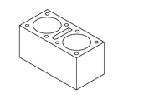 | 8" x 8" x 16" THRU-WALL | 42.0 lbs. | 7-5/8" x 7-5/8" x 15-5/8" | 6.94 | 1.13 | 194 x 194 x 407 | 12.0

